POWER BI ASSIGNMENT 2
DAX & Data Visualization – E-Commerce Sales Analysis

1. Project Overview and Objective
This project analyses e-commerce sales data using Microsoft Power BI. The main objective is to transform the raw order data, create useful DAX calculations, and build visualizations that help understand sales, targets, profitability, order volume, and product-level performance.

2. Data Sources
Three CSV files were used for the analysis:
- List of Orders.csv
- Order Details.csv
- Sales target.csv
The assignment requires data modelling to be completed before visualization, with relationships established between the required tables.
Screenshots
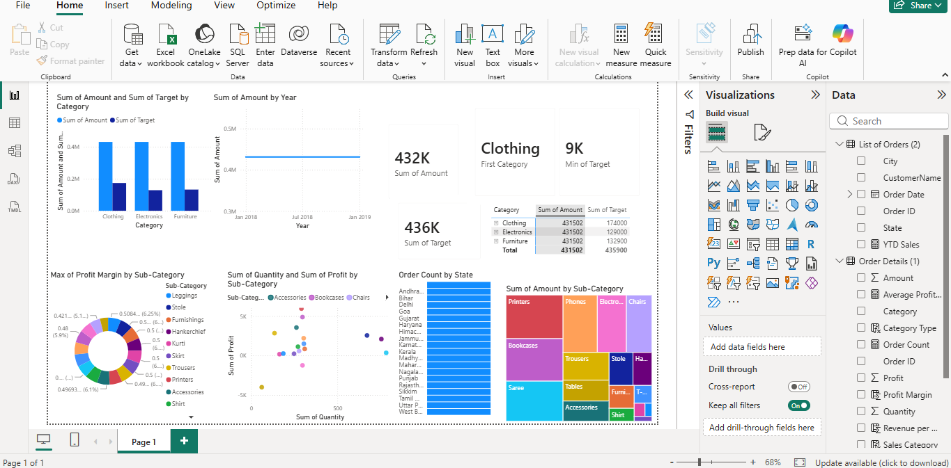

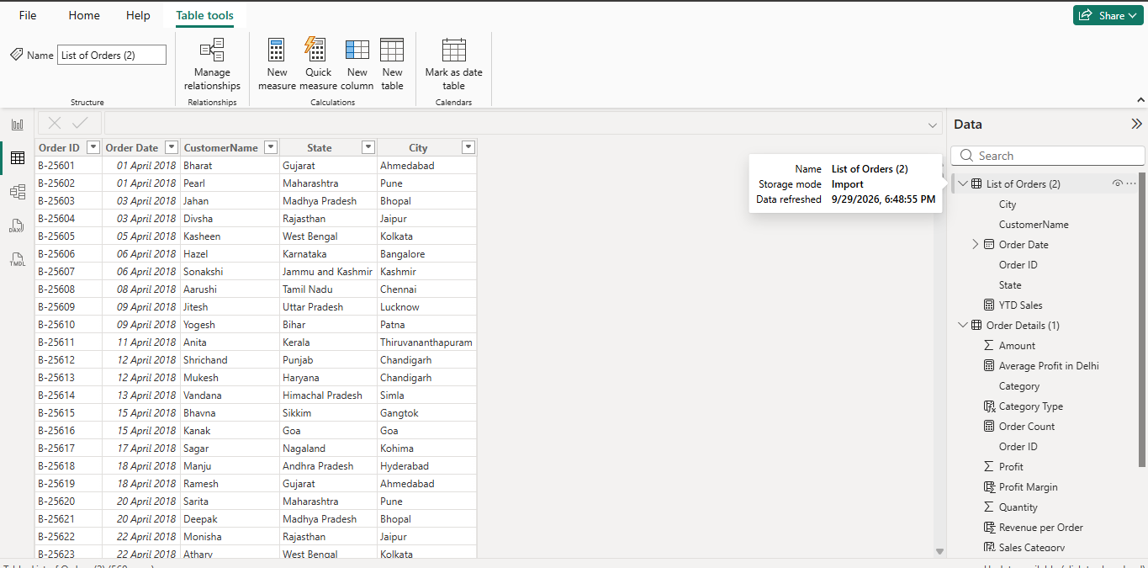

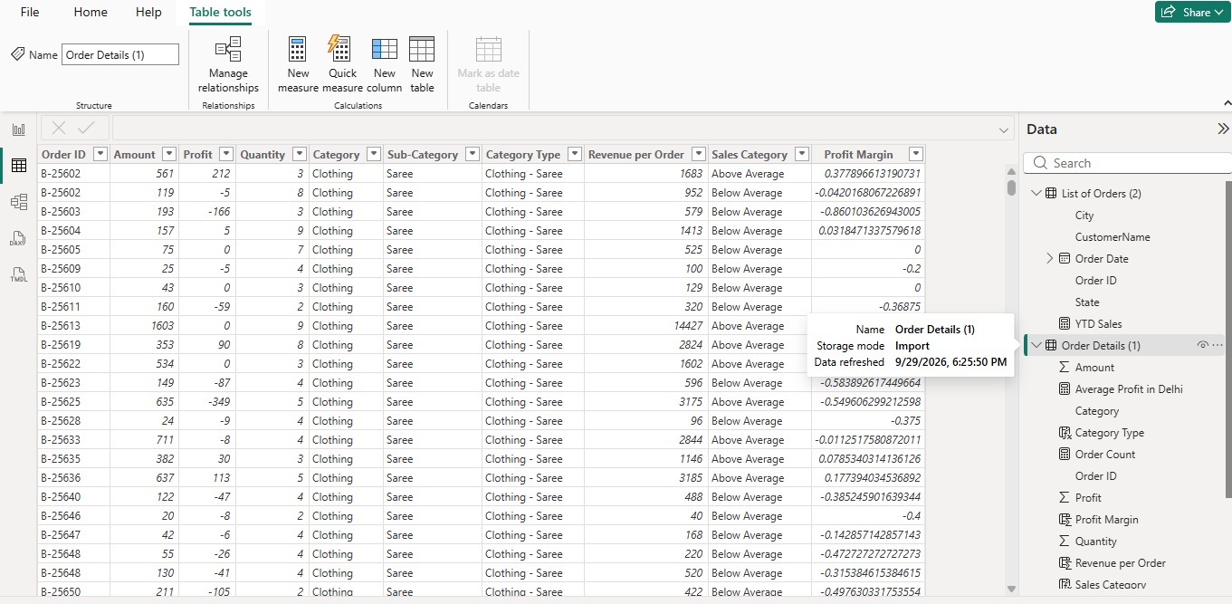

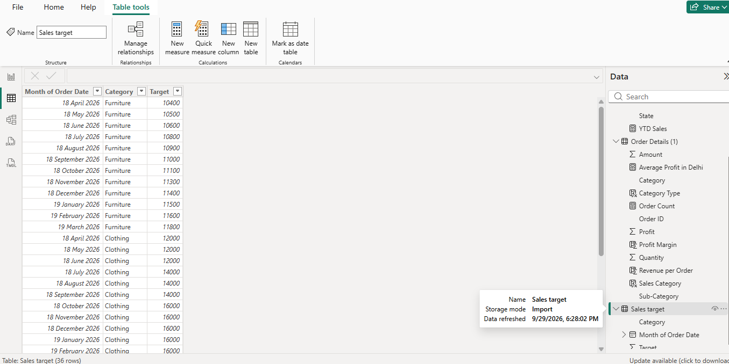

3. Data Modelling and Preparation
The imported tables were reviewed in Power BI and the required fields were prepared for analysis. The order information provides fields such as Order Date, City and State, while Order Details provides Category, Sub-Category, Amount, Quantity and Profit. The Sales Target table provides target values by month and category.
The data was then used to create calculated columns and measures required by the assignment.

4. DAX Calculated Columns
Calculated Column | Purpose | DAX Formula
Category Type | Combines Category and Sub-Category into one field. | Category Type = [Category] & " - " & [Sub-Category]
Revenue per Order | Calculates revenue using Amount × Quantity. | Revenue per Order = [Amount] * [Quantity]
Sales Category | Classifies orders as Above Average or Below Average based on Amount. | Sales Category = IF([Amount] > AVERAGE([Amount]), "Above Average", "Below Average")
Profit Margin | Calculates profit as a proportion of sales amount for profit-margin analysis. | Profit Margin = DIVIDE([Profit], [Amount])

5. DAX Measures
Measure | Purpose | DAX Formula
Order Count | Counts order-detail records. | Order Count = COUNTROWS('Order Details (1)')
Average Profit in Delhi | Calculates average profit for Delhi orders. | Average Profit in Delhi = CALCULATE(AVERAGE('Order Details (1)'[Profit]), 'List of Orders (2)'[City] = "Delhi")
YTD Sales | Calculates cumulative sales up to the current order date. | YTD Sales = CALCULATE(SUM('Order Details (1)'[Amount]), FILTER(ALL('List of Orders (2)'[Order Date]), 'List of Orders (2)'[Order Date] <= MAX('List of Orders (2)'[Order Date])))
SCREENSHOTS: Insert your completed Power BI visual/report screenshots here.

6. Power BI Visualizations
- Sales Target Achievement by Category: Clustered column chart comparing actual sales amount with sales target by category.
- Max Profit Margin by Sub-Category: Donut chart showing the maximum profit margin for each sub-category.
- Monthly Sales Trend: Line chart showing sales amount over order dates/months.
- Profit and Quantity by Sub-Category: Scatter chart comparing quantity sold and profit, with sub-category used for identification.
- Total Sales Amount and Target: Cards displaying total sales amount and total target.
- Minimum Target Analysis: Multi-row card showing category and minimum target values.
- Sales Performance Matrix: Matrix comparing sales across categories and months, with target values included.
- Sales Distribution by Sub-Category: Treemap showing sales amount distribution across sub-categories.
- Order Count Analysis by State: Funnel chart showing order count distribution across states.
Note: The Geographic Sales Analysis map was attempted, but the map visual was disabled in the Power BI environment. Therefore, the map was not included in the final dashboard.

7. Key Analysis and Findings
- The dashboard provides a comparison between actual sales and the assigned sales targets at category and month levels.
- The profit-margin visualization helps compare profitability performance across different product sub-categories.
- The monthly sales trend provides a time-based view of sales performance and helps identify changes across periods.
- The scatter chart allows profit and quantity to be viewed together for different sub-categories.
- The matrix provides a detailed category-by-month view for comparing actual sales with targets.
- The treemap highlights the relative contribution of different sub-categories to total sales.
- The funnel chart summarizes order volume across states.

8. Conclusion
This Power BI assignment demonstrates an end-to-end e-commerce sales analysis workflow. The project uses calculated columns and DAX measures to derive useful business metrics and combines multiple Power BI visualizations to present sales, target, profit, quantity, product and geographic-related information. The completed dashboard provides a consolidated view that can support further sales performance analysis.

